Case Name:

*案件名称：*

County: Case No:

*县：* *案件编号：*

**Firearm Identification Worksheet**  
(*You may attach this to the petition*.)

***枪支辨认表*** *（您可以将其附在申请上。)*

1. Does the restrained person own or have access to any firearms? [ ] Yes [ ] No

*受限制人是否拥有或可以接触到任何枪支？[-]是 [-]否*

2. Does the restrained person have a concealed pistol license (CPL)? [ ] Yes [ ] No

*受限制人是否有隐蔽持枪证(CPL)？[-]是 [-]否*

3. When was the last time you saw the firearm/s?

*您最后一次看到枪支是什么时候？*

4. Do you know where the restrained person keeps the firearm/s? [ ] Yes [ ] No

*您知道受限制人把枪放在哪里吗？[-]是 [-]否*

If yes, check all that apply:

*如果是，请勾选所有适用项：*

[ ] On their Person [ ] In their Car [ ] In their Home [ ] Storage Unit [ ] In a Safe

*随身携带 [-]在车里 [-]在家里 [-]在储物格里 [-]在保险箱里*

5. To the best of your knowledge, are the guns typically loaded?

*据您所知，这些枪是否都装了子弹？*

[ ] Yes [ ] No [ ] I don’t know

*是 [-]不是 [-]我不知道*

6. On a scale from 1 to 5 (1 being “not very important and 5 being “very important”), how important are the firearms to the restrained person?

*按1到5（1表示“不太重要”，5表示“非常重要”）描述枪支对受限制人的重要性如何？*

1 2 3 4 5

7. What does the restrained person generally use the firearms for? (*check all that apply*)

*受限制人一般使用枪支做什么？（可多选）*

[ ] Hunting [ ] Collecting [ ] Target Shooting [ ] Protection [ ] Other:

*狩猎 [-]收藏 [-]目标射击 [-]保护 [-]其他：*

8. Does the respondent possess explosives? [ ] Yes [ ] No [ ] I don’t know

*被告是否拥有爆炸物？[-]是 [-]否 [-]我不知道*

9. Has the restrained person ever ordered parts of firearms or possess parts that could be assembled into a working firearm? [ ] Yes [ ] No [ ] I don’t know

*受限制人是否订购过枪支零件或拥有可组装成可用枪支的零件？[-]是 [-]否 [-]我不知道*

10. Does the restrained person own or possess any other dangerous weapons you believe should be surrendered? [ ] Yes [ ] No If yes, list them here:

*受限制人是否拥有或持有您认为应该上交的任何其他危险武器？[-]是 [-]否 如果是，请在此列出：*

The pictures below are examples of the most common guns. If you recognize any of the pictures below as similar to the one/s your partner has, please circle it and write in the circle how many your partner has.

*下面的图片是最常见的枪的例子。如果您认为下面的任何一张图片与您伴侣的相似，请圈出，并在圆圈中写下您的伴侣有几把。*

**Handgun**

***手枪***

|  |  |  |
| --- | --- | --- |
|  |  | |
|  | |  | |

|  |  |
| --- | --- |
|  |  |

**Semi-automatic Rifle**

***半自动步枪***

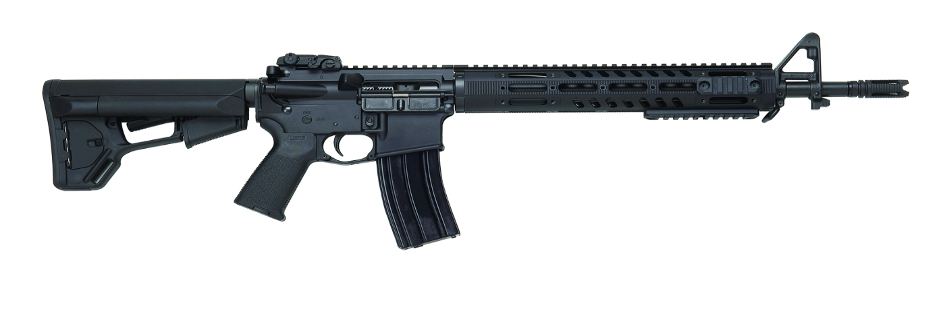

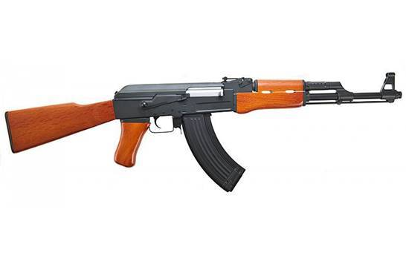

**Rifle**

***步枪***

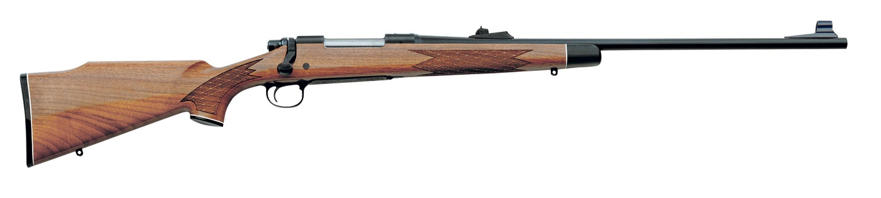

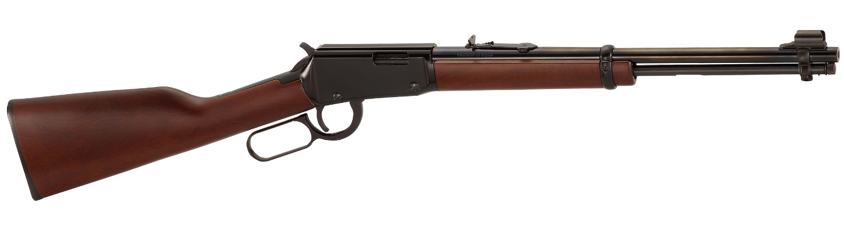

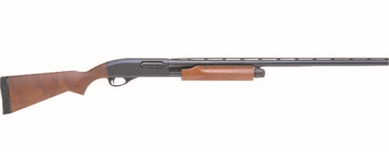

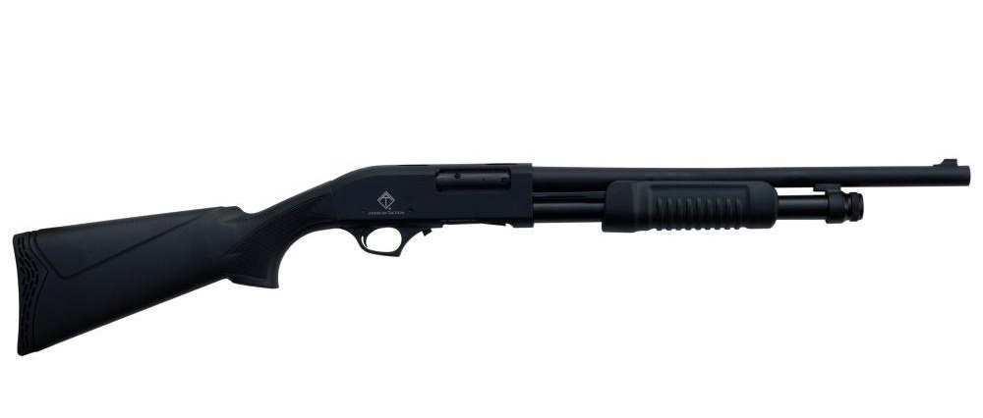

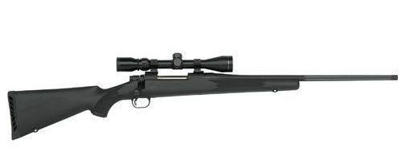

**Unassembled Firearms**

***未组装的枪支***

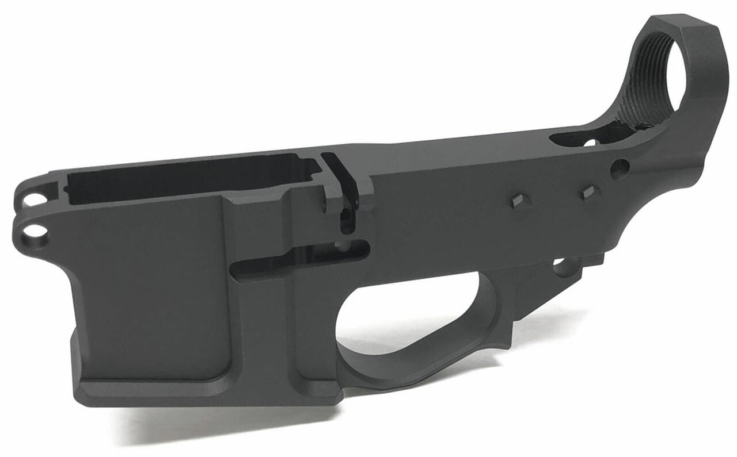

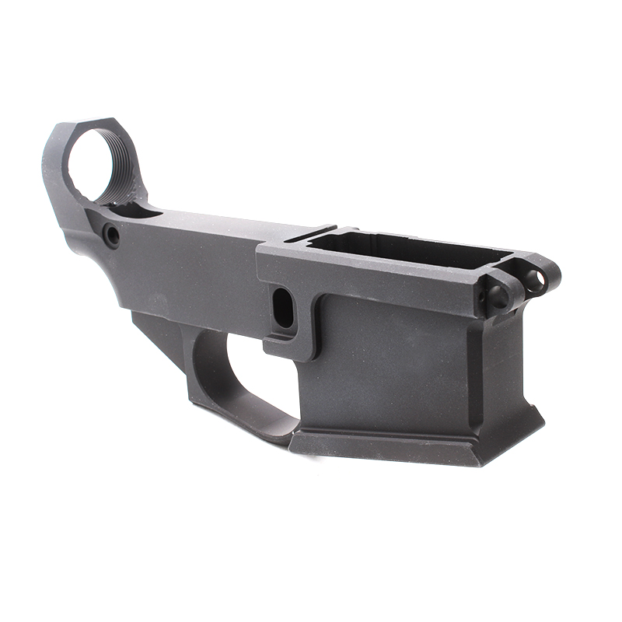

Signed Dated

*签名* *日期*